**Reading inputs from a text file with inputs like**

1.0 2.0 3.0 4.0 asia india

5.0 6.0 7.0 8.0 europe france

9.0 10.0 11.0 12.0 asia india

13.0 14.0 15.0 16.0 europe germany

17.0 18.0 19.0 20.0 europe france

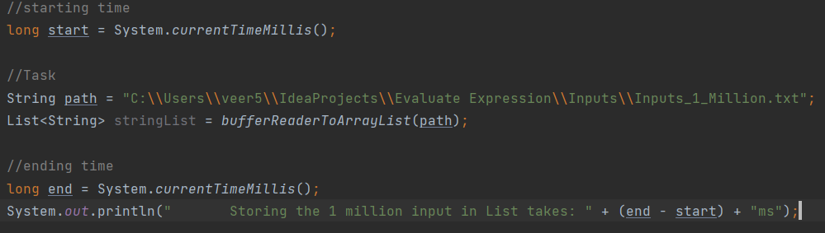

**Reading inputs from a text file with inputs like**

1.0

5.0

9.0

13.0

17.0

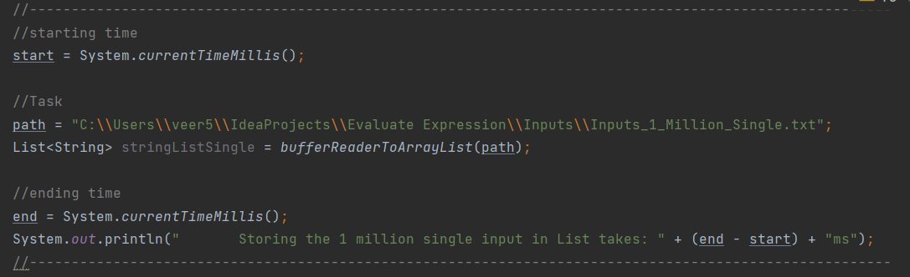

**Output:**

Storing the 1 million input in List takes: 484ms

**Reading inputs from a text file with inputs like**

1.0 2.0 3.0 4.0 asia india

5.0 6.0 7.0 8.0 europe france

9.0 10.0 11.0 12.0 asia india

13.0 14.0 15.0 16.0 europe germany

17.0 18.0 19.0 20.0 europe france



**Output:**

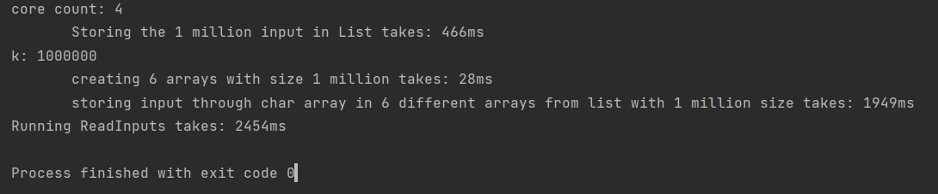

core count: 4

Storing the 1 million input in List takes: **466ms**

k: 1000000

creating 6 arrays with size 1 million size takes: **28ms**

storing input through char array in 6 different arrays from list with 1 million size takes: **1949ms**

Running ReadInputs takes: 2454ms

**Storing data from string list to 6 different arrays:**

1. **Through Char Array**

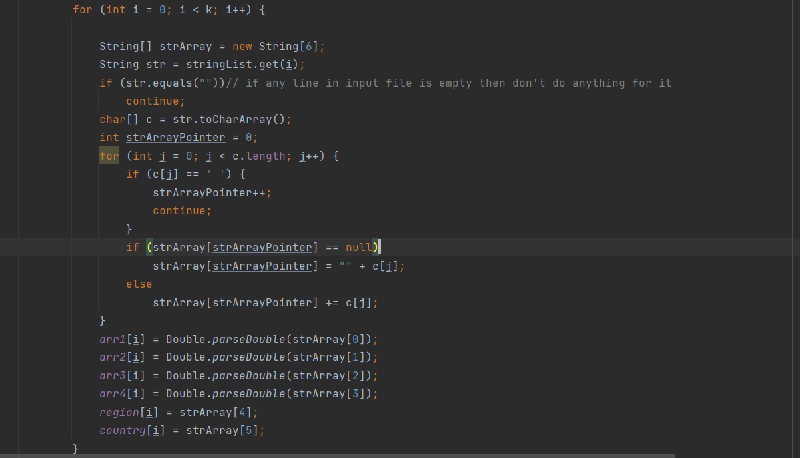

**Output:**

storing input through char array in 6 different arrays from list with 1 million size takes: **2117ms**

1. **Through Scanner**

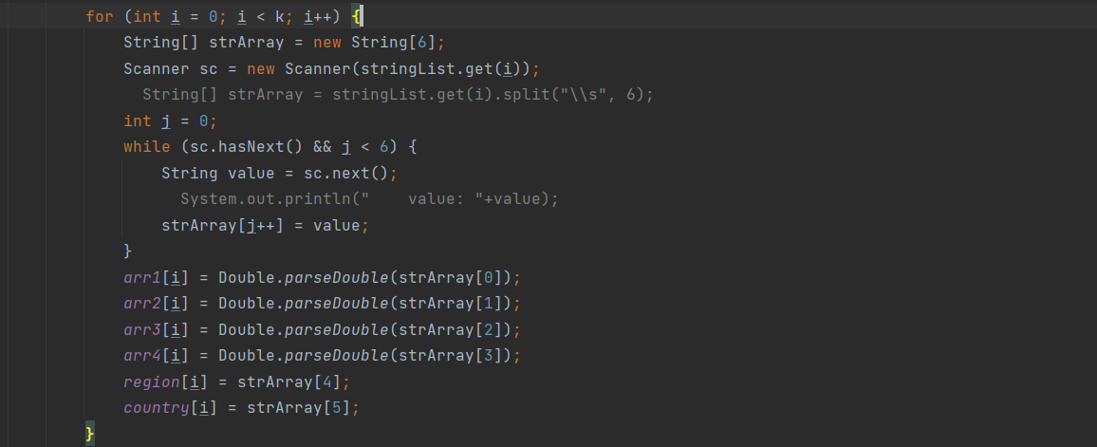

storing input through scanner in 6 different arrays from list with 1 million size takes: **9459ms**

**Final Program(Single Threading) Output:**

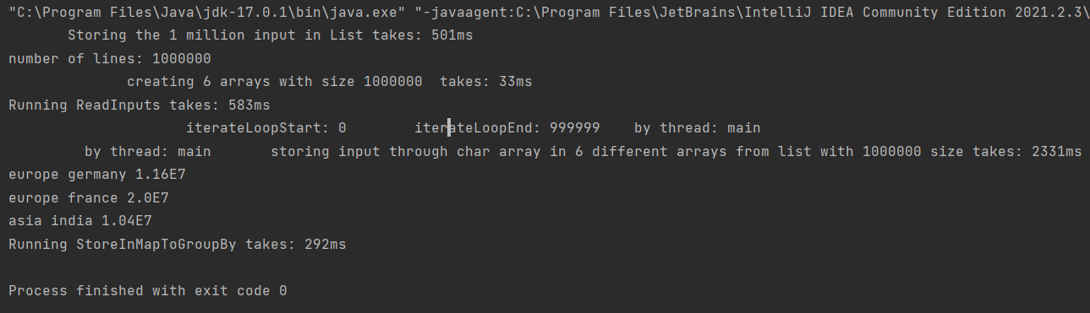

Storing the 1 million input in List takes: **501ms**

number of lines: 1000000

creating 6 arrays with size 1000000 takes: **33ms**

Running ReadInputs takes: **583ms**

iterateLoopStart: 0 iterateLoopEnd: 999999 by thread: main

by thread: main storing input through char array in 6 different arrays from list with 1000000 size takes: **2331ms**

**europe germany 1.16E7**

**europe france 2.0E7**

**asia india 1.04E7**

Running StoreInMapToGroupBy takes: **292ms**

**Output by using Multithreading**

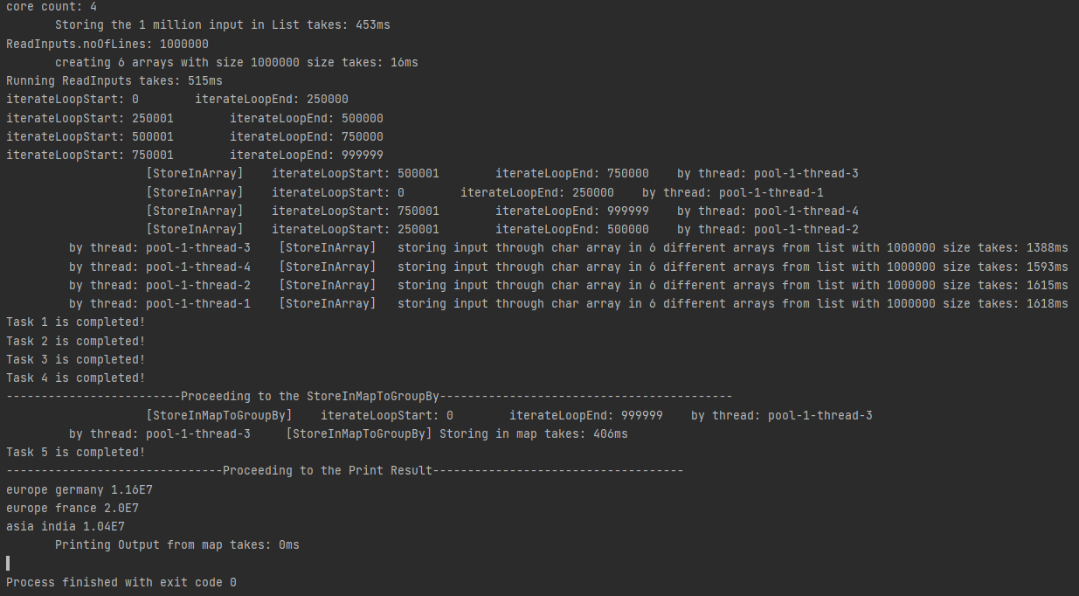

core count: 4

Storing the 1 million input in List takes: **453ms**

ReadInputs.noOfLines: 1000000

creating 6 arrays with size 1000000 size takes: **16ms**

Running ReadInputs takes: **515ms**

iterateLoopStart: 0 iterateLoopEnd: 250000

iterateLoopStart: 250001 iterateLoopEnd: 500000

iterateLoopStart: 500001 iterateLoopEnd: 750000

iterateLoopStart: 750001 iterateLoopEnd: 999999

[StoreInArray] iterateLoopStart: 500001 iterateLoopEnd: 750000 by thread: pool-1-thread-3

[StoreInArray] iterateLoopStart: 0 iterateLoopEnd: 250000 by thread: pool-1-thread-1

[StoreInArray] iterateLoopStart: 750001 iterateLoopEnd: 999999 by thread: pool-1-thread-4

[StoreInArray] iterateLoopStart: 250001 iterateLoopEnd: 500000 by thread: pool-1-thread-2

by thread: pool-1-thread-3 [StoreInArray] storing input through char array in 6 different arrays from list with 1000000 size takes: **1388ms**

by thread: pool-1-thread-4 [StoreInArray] storing input through char array in 6 different arrays from list with 1000000 size takes: **1593ms**

by thread: pool-1-thread-2 [StoreInArray] storing input through char array in 6 different arrays from list with 1000000 size takes: **1615ms**

by thread: pool-1-thread-1 [StoreInArray] storing input through char array in 6 different arrays from list with 1000000 size takes: **1618ms**

Task 1 is completed!

Task 2 is completed!

Task 3 is completed!

Task 4 is completed!

-------------------------Proceeding to the StoreInMapToGroupBy------------------------------------------

[StoreInMapToGroupBy] iterateLoopStart: 0 iterateLoopEnd: 999999 by thread: pool-1-thread-3

by thread: pool-1-thread-3 [StoreInMapToGroupBy] Storing in map takes: **406ms**

Task 5 is completed!

-------------------------------Proceeding to the Print Result------------------------------------

**europe germany 1.16E7**

**europe france 2.0E7**

**asia india 1.04E7**

Printing Output from map takes: **0ms**